AINT351 – MACHINE LEARNING

10555972 | Computer Science | 12th December 2019

Contents

1. Training Data Generation 3

1.1. Display Workspace of Revolute Arm 3

1.2. Configurations of a Revolute Arm 5

2. Implement a 2-Layer Network 6

2.1. Implement the Network Feedforward Pass 6

2.2. Implement 2-Layer Network Training 7

2.3. Train Network Inverse Kinematics 8

2.4. Test and Interpret Inverse Model 9

3. Path Through a Maze Using Q-Learning 12

3.1. Generate Random Start State 13

3.2. Build a Reward Function 14

3.3. Generate a Transition Matrix 14

3.4. Initialize Q-Values 15

3.5. Implement Q-Learning Algorithm 15

3.6. Run Q-Learning 17

3.7. Exploitation of Q-Values 18

4. Move arm Endpoint Through Maze 19

4.1. Generate Kinematic Control to Revolute Arm 20

4.2. Animated Revolute Arm Movement 20

# Training Data Generation

The provided Revolute Forward Kinematics 2D function is used to be able to output the arm end points by using the arms joint angles, the length of the arms and the base origin of the arms. The end points that are generated from this function will then later be used to train a neural network.

## Display Workspace of Revolute Arm

To display the workspace of the revolute arm I generated a random dataset between the values of 0 and π. The dataset had uniform distribution and contained 2x1000 samples. This dataset contains the angles that will be passed through the forward kinematics to calculate the end points and show the workspace of the arm.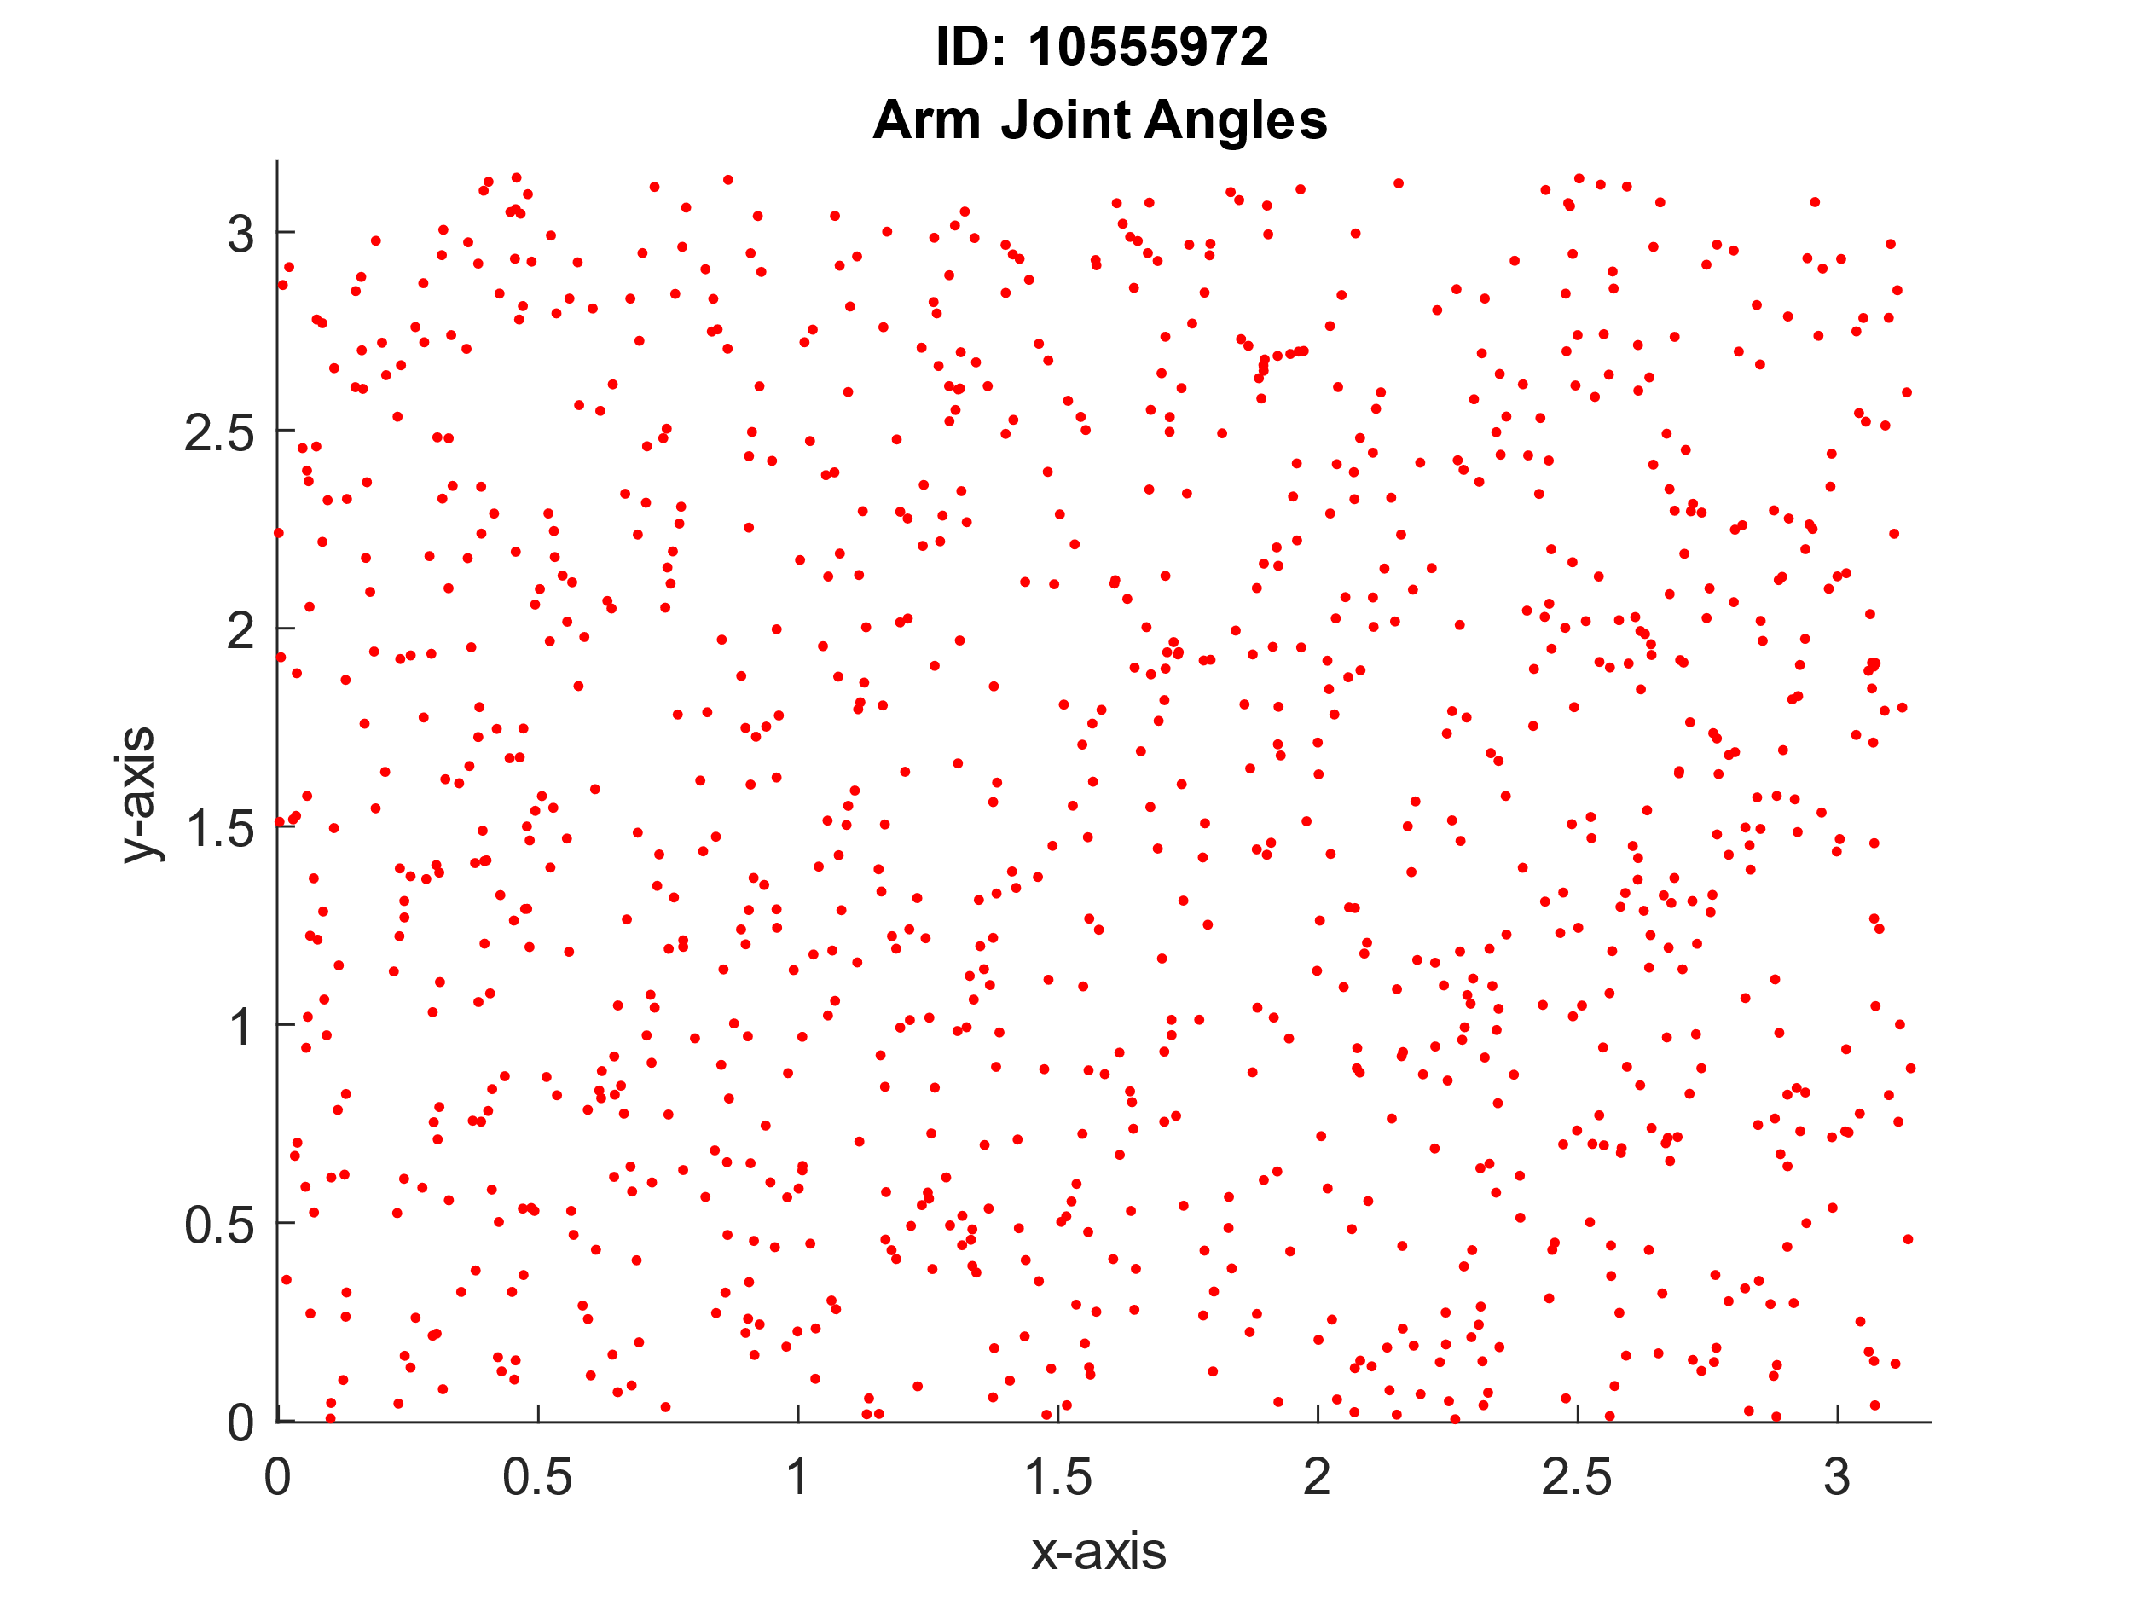 I then set the parameters for the Revolute Forward Kinematics function to use, the arm lengths for before and after the elbow were set to 0.4 and the base origin coordinates were set to (0, 0). Passing in these values and the joint angles previously generated, the function produces the correspdoning end points. Due to the arm only having 2 degrees of freedom the useful range of the end points is rather limited. This could be increase by adding a third joint to the arm, allowing it to move freely throughout the plane.

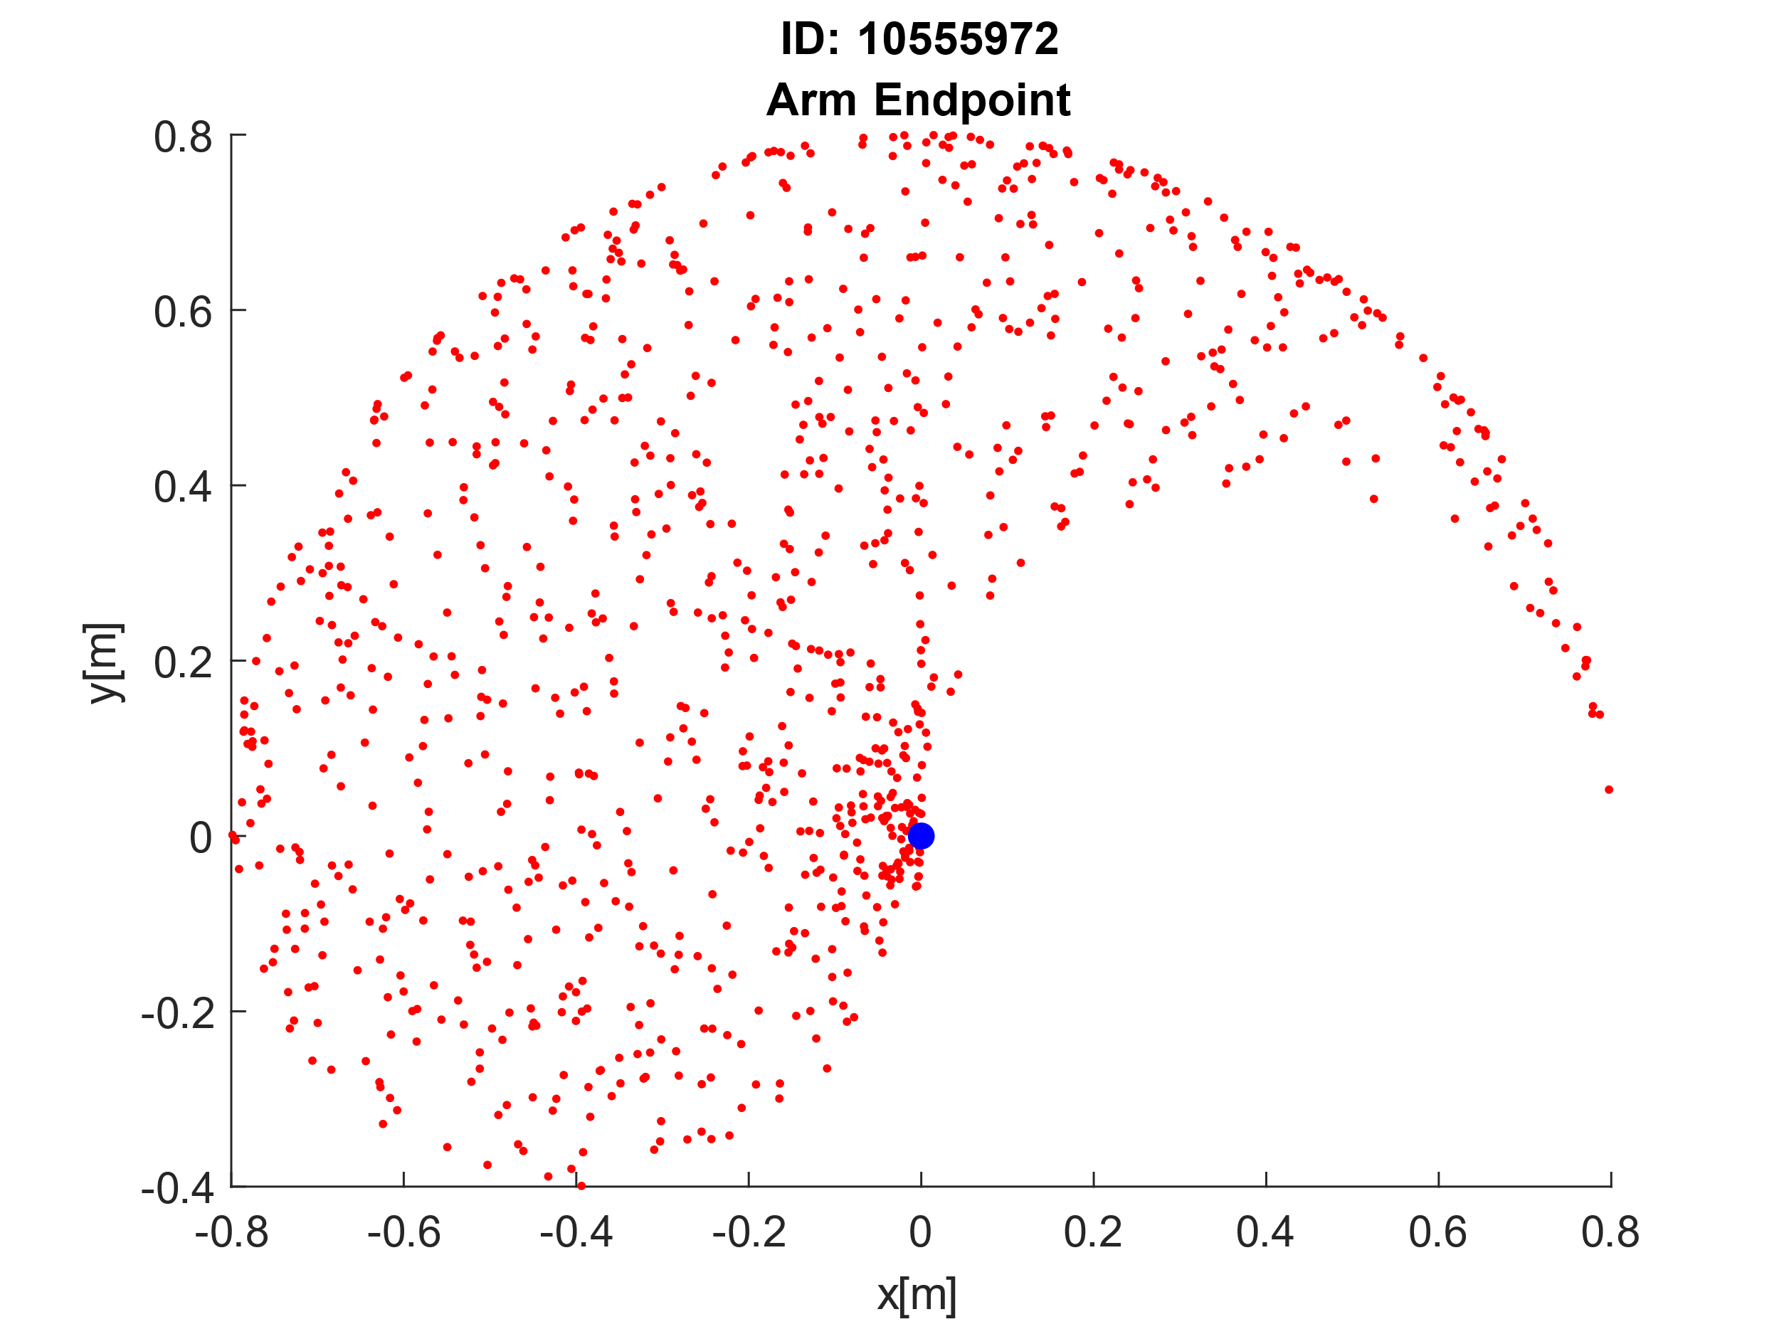

% Defining variables

armLength = [0.4;0.4];

baseOrigin = [0, 0];

samples = 1000;

% Generating 2 x samples between 0 - pi

angles = pi * rand(2,samples);

% Run angles through forward kinematics

[P1, P2] = RevoluteForwardKinematics2D(armLength, angles, baseOrigin);

% Plot randomly generated angles

figure

hold on

title({'ID: 10555972', 'Arm Joint Angles'});

xlabel('x-axis');

ylabel('y-axis');

plot(angles(1,:), angles(2,:), 'r.');

% Plot end points

figure

hold on

title({'ID: 10555972', 'Arm Endpoint'});

xlabel('x[m]');

ylabel('y[m]');

plot(P2(1,:), P2(2,:), 'r.')

plot(baseOrigin(1), baseOrigin(2), 'b.', 'MarkerSize', 20);

## Configurations of a Revolute Arm

To help illustrate the arm configurations I have plotted 10 elbow and end points locations and the arm between them. This has been done by using 10 of the randomly generated set of angles previously and running it through the forward kinematics function. This plot gives a greater understanding about the movement of the arm and the range of motion it can have.

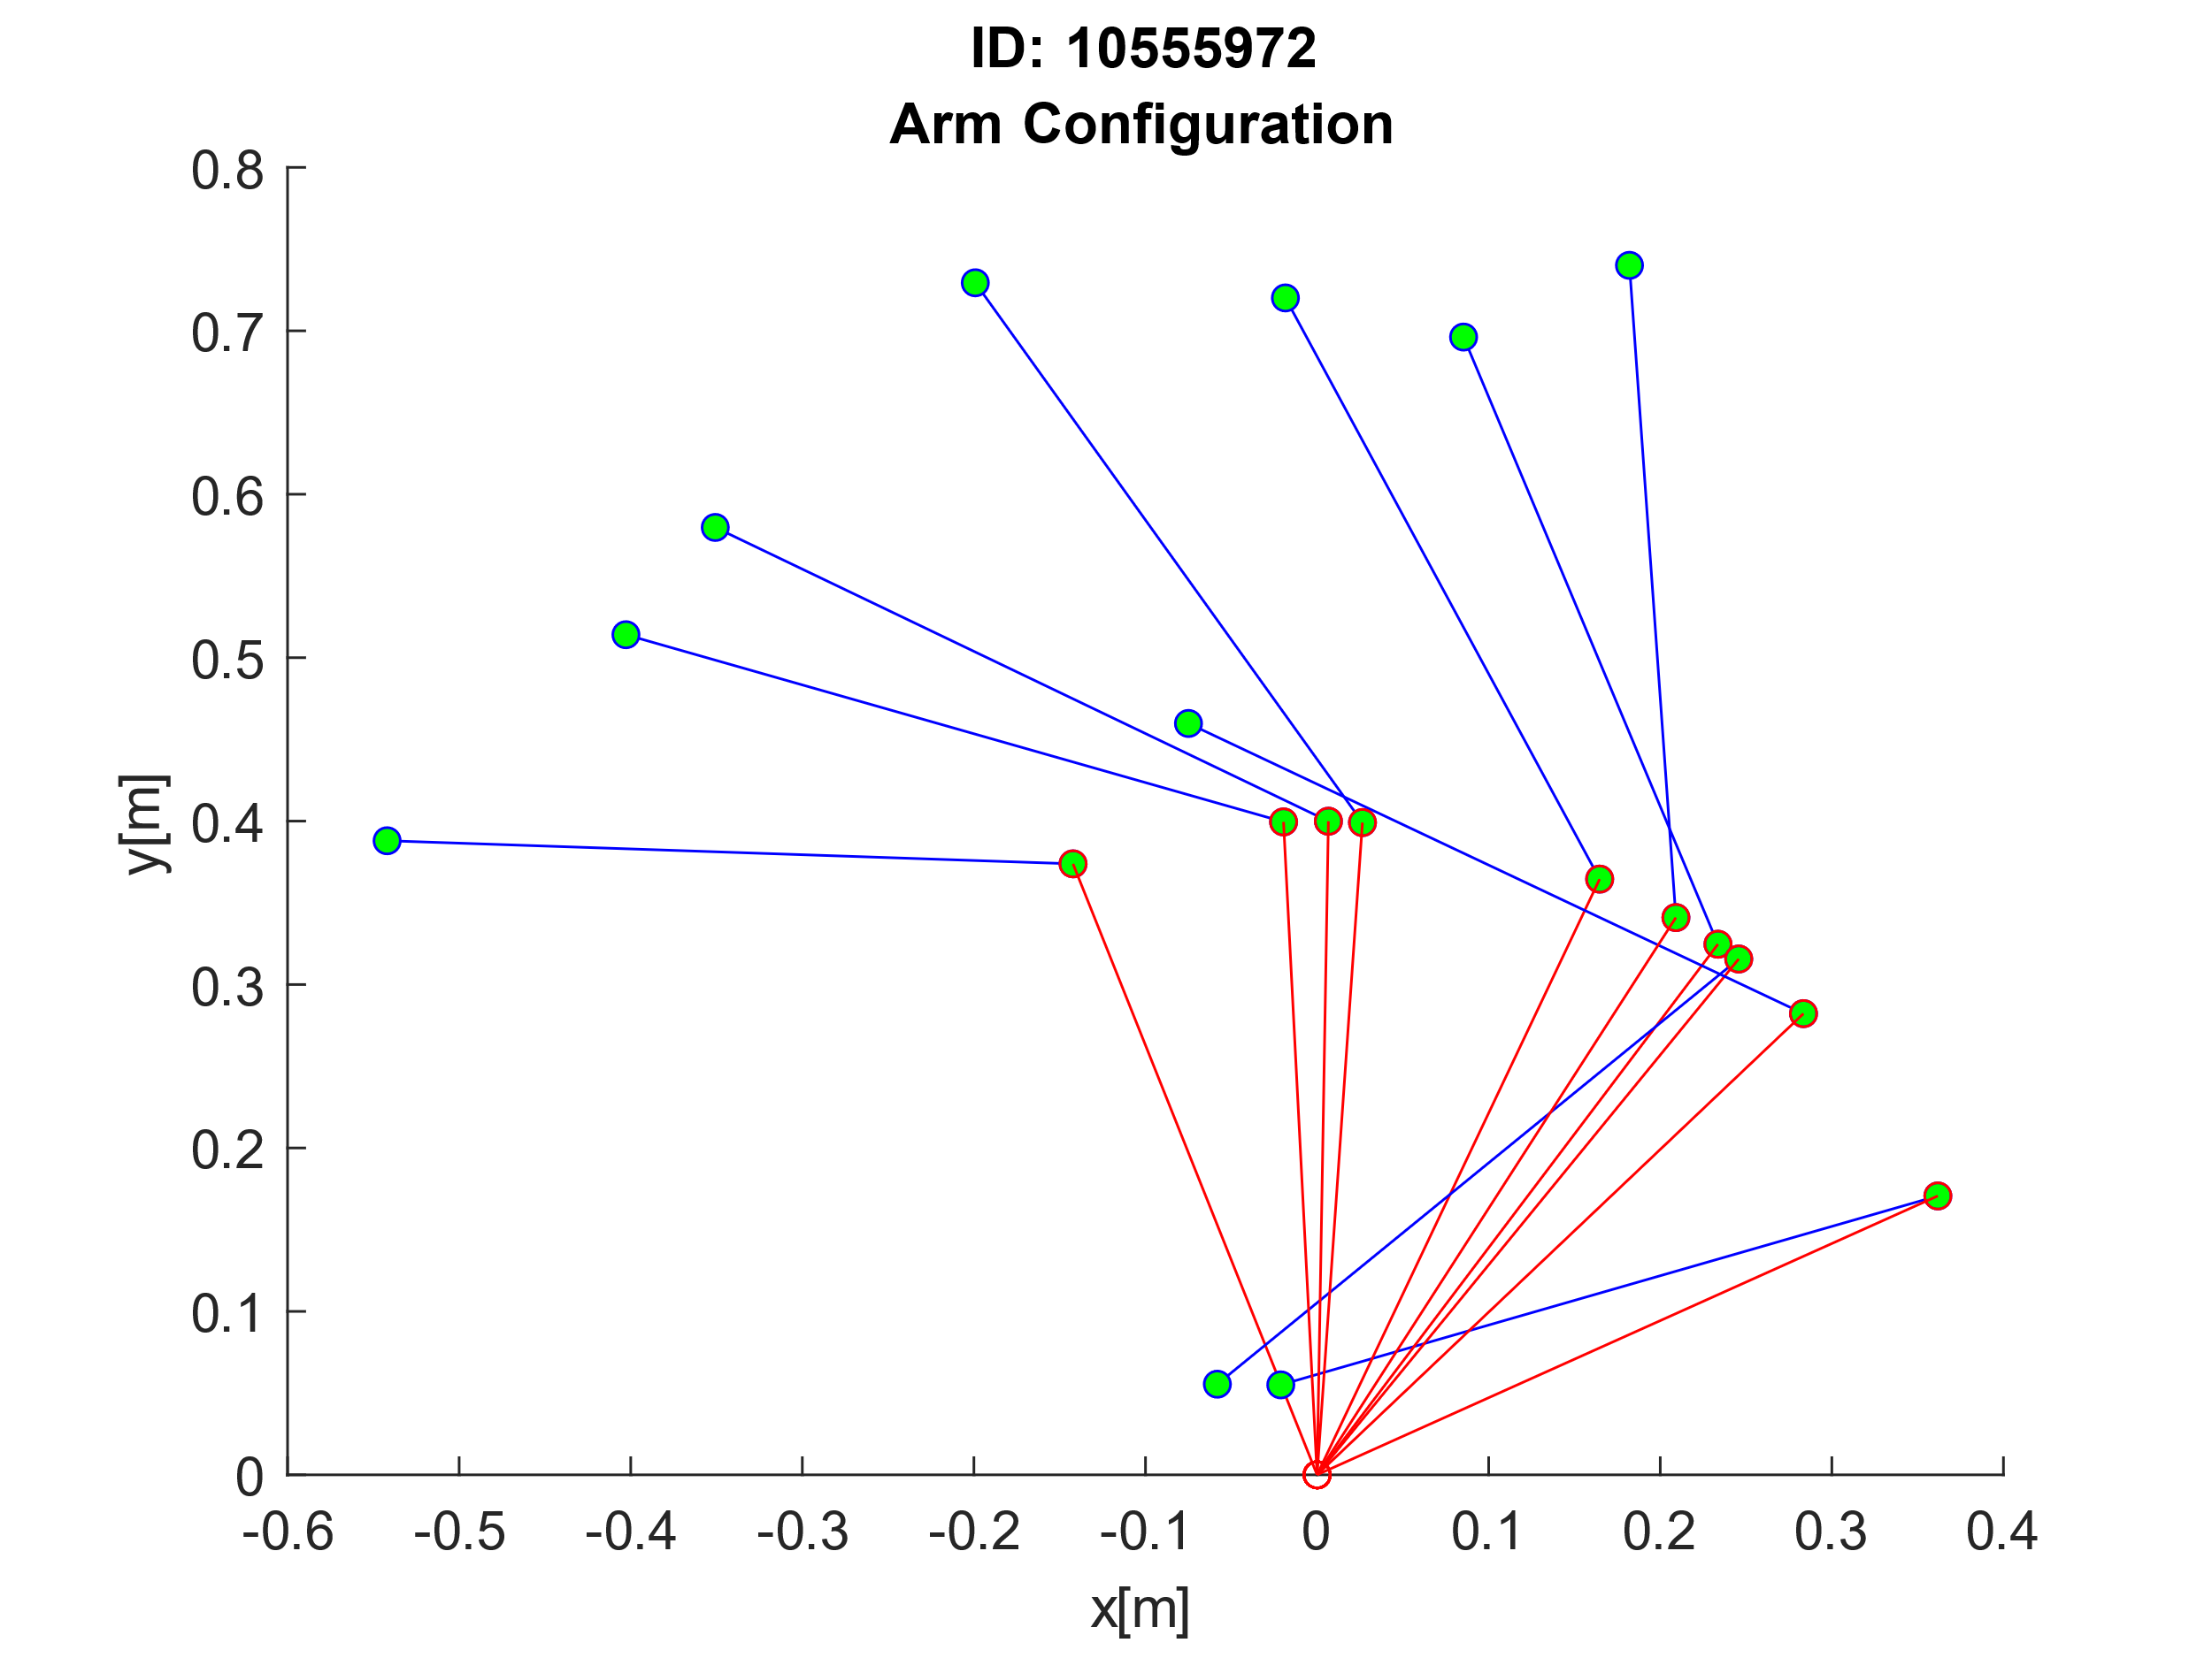

% Plot 10 arm configurations

figure

title({'ID: 10555972', 'Arm Configuration'});

xlabel('x[m]');

ylabel('y[m]');

for i = 1:10

hold on

% Plotting from elbow to end of arm

plot([P1(1,i) P2(1,i)],[P1(2,i) P2(2,i)], 'b-o', 'MarkerSize', 5, 'MarkerFaceColor', 'green');

% Plotting from origin to elbow

plot([P1(1,i) baseOrigin(1)], [P1(2,i) baseOrigin(2)], 'r-o', 'MarkerSize', 5);

end

# Implement a 2-Layer Network

The next step is to build a multi-layer neural network which will be used to learn and calculate the robot arm’s inverse kinematics. To do this I will build a network that has 2 inputs (plus a third for the bias), a layer of hidden nodes (the diagram shows 2 but this can be n number of nodes) and two outputs. The network is fully connected by weight matrices on both the first and the second layer and will be passed through a sigmoid function in the hidden layer.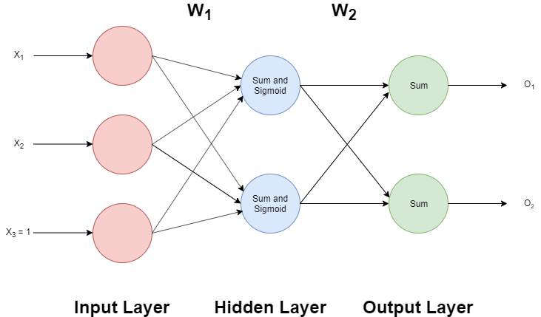

The input data will be the arm endpoints that have been calculated from the forward kinematics function and the output will be the inverse of the kinematics, so in this case it will be the randomly generated dataset between 0 and π. I have chosen to have two outputs for this network instead of one as it will allow me to output both the x and the y coordinates at the same time instead of having to have two separate networks and pass through each one.

## Implement the Network Feedforward Pass

To start I created a feed forward function which takes as parameters the input data and the weight matrices for the network. This function completes a one whole pass of the network to calculate the output which is then returned by the function. I have also created a function which calculates and returns the sigmoid activation of any given input. A sigmoid function is useful because it is non-linear and reduces the range between 0 and 1 whilst keeping continuous values.

% This function is used to carry out a feedforward pass of the network

% given its input data and both weight matrices.

function output = FeedForward(input, W1, W2)

% Add bias to input matrix

input = [input; 1];

% Calculate output from hidden layer

net = W1*input;

% Sigmoid activation function

a2 = SigmoidFunction(net);

% Adding bias to activation from hidden layer

a2hat = [a2; 1];

% Calculating output from output layer

output = W2*a2hat;

end

% Function to carry out the sigmoid acivation calculation

function result = SigmoidFunction(net)

result = 1 ./ (1+(exp(-net)));

end

## Implement 2-Layer Network Training

To train a network we must first calculate the error of the output, this is done by finding the difference between the target output and the actual output. Neural networks are a type of supervised learning, so the system requires the target data to be able to calculate the error. To do this for a 2-layer network backpropagation should be used to ensure that the entire network is updated as the second layer takes the first layer’s weights as inputs, so adjusting just the first layer would have a knock-on effect to the second layer. To adjust the weights from the first layer we can then use the delta term calculated from the second layer to be the error term for the first layer.

The function below runs through a feedforward pass and then backpropagates to adjust the weights accordingly. The function takes the input data, target data and both weight matrices, and then returns the updated weight matrices. Delta 3 is equal to the error between the input data and the target data. Delta 2 is equal to the error back propagated from the higher level (the weight matrix has its bias removed before this calculation), multiplied by a scaler due to the sigmoid function in the hidden layer.

The error gradient for both weight matrices is then calculated by using the delta for that layer multiplied by the input of that layer. The weights are then updated and returned by taking away the gradient multiplied by the learning rate.

% Function to train the network given input data, target data and the weight matrix. By calculating the error gradient and updating the weight values.

function [W1, W2] = Train(input, target, W1, W2)

% Setting learning rate

learningRate = 0.01;

% FEEDFORWARD PASS

% Calculate output from hidden layer and add bias

input = [input; 1];

net = W1*input;

% Sigmoid activation function

a2 = SigmoidFunction(net);

% Adding bias to activation from hidden layer

a2hat = [a2; 1];

% Calculating output from output layer

o = W2*a2hat;

% BACKPROPAGATION

% Delta 3 is equal to the output error

delta3 = -(target-o);

% Removing bias from weights

for i = 1:size(W2,2)-1

W2Hat(1,i) = W2(1,i);

W2Hat(2,i) = W2(2,i);

end

% Delta 2 is equal to the error from the second layer multiplied by a

scaling factor due to the sigmoid function

delta2 = (W2Hat'*delta3).*a2.*(1-a2);

% Calculating the error gradient

errGradientW1 = delta2*input';

errGradientW2 = delta3*a2hat';

% Updating weights using the learning rate and error gradient

W1 = W1 - learningRate*errGradientW1;

W2 = W2 - learningRate*errGradientW2;

end

## Train Network Inverse Kinematics

It is possible to calculate the inverse kinematics for a robot arm with only 2 degrees of freedom. However, if this number was greater, then the calculation would become much more difficult. So, in this case we want the network to learn inverse kinematics for us. To do this, we will feed in the arm end points as the input data and some randomly generated angles as the target data. Due to my network having 2 outputs we will only have to train one network.

Below I have plotted the error of the neural network as the training happens. To calculate the error, I used the following formula: . I calculated the error for each data point and then took the mean for each iteration. I ran the training for 1000 iterations and the error tends towards 0.

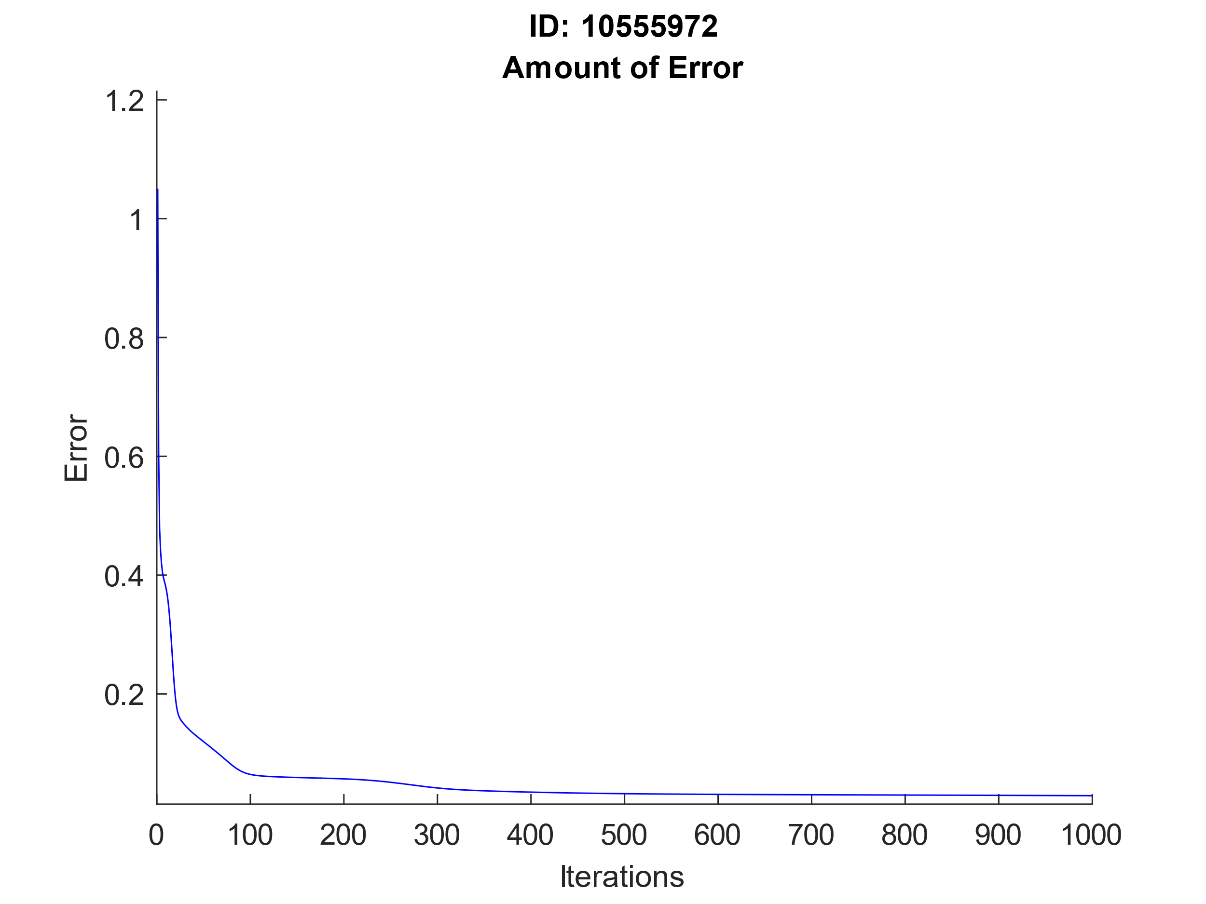

## Test and Interpret Inverse Model

After the network has been trained, I can carry out feedforward passes on arm end points to get the angles. I have generated a new random dataset and used the Forward Kinematics function to get the endpoints. I have then completed the feed forward pass on this data because it is different data from the data that the network was trained on. As you can see below the results are within the correct range and the output is fairly accurate. For these results I have used 1000 iterations, 10 hidden nodes and a learning rate of 0.01 for training. These values have been chosen to ensure that overfitting does not occur when training my network. Overfitting is when the training error becomes so low on the data that it is being trained on that the error on new data being passed through the network is very large. I have found that these values provide the best results while in turn not taking a considerably long time to train the network.

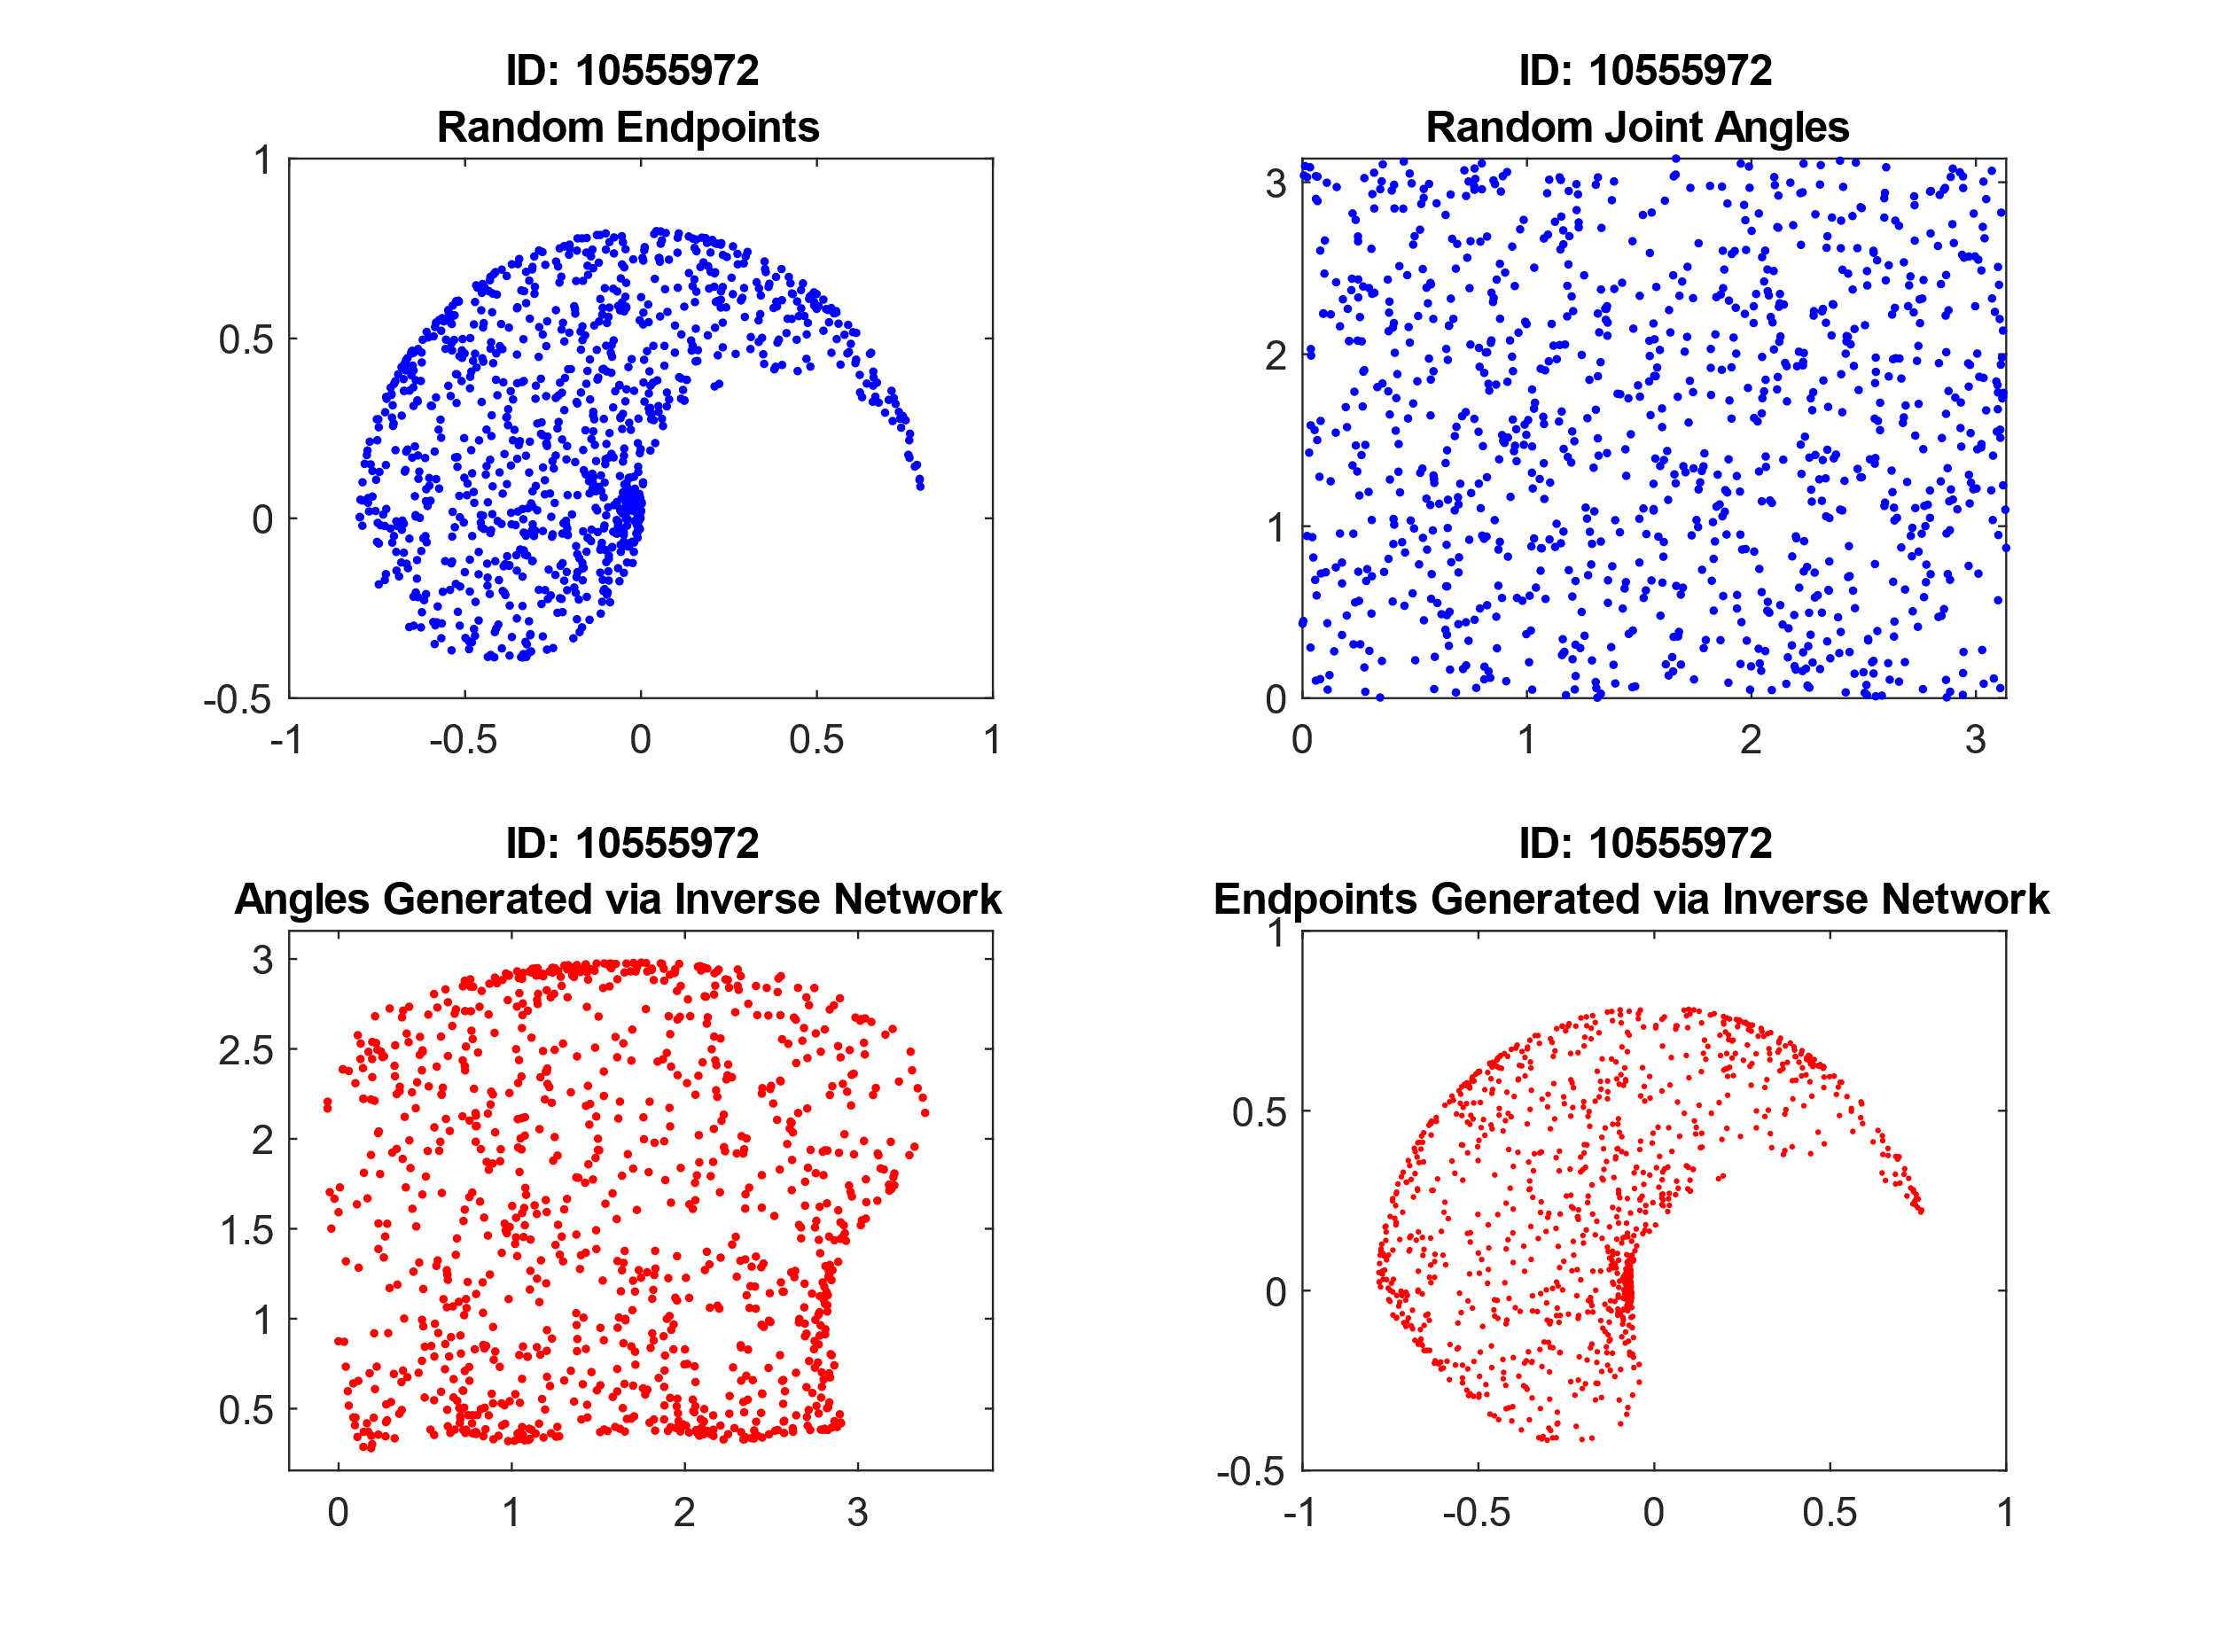

To better improve the accuracy of a neural network it is sometimes feasible to randomize the order of data when training the network this is so that there is no correlation between data and that the order of the data has no effect on the output of the network. Therefore, I tried randomizing the training data as shown below and this had little to no effect on the training of the network. This could be because the data set it relatively small and because it is being trained on a random set of data.

% Matrix from 1 to samples in random order

r1 = randperm(samples);

% Training the data for the number of iterations for each data point

for i = 1:iterations

for j = 1:samples

[W1, W2, err(j)] = Train(P2(:,r1(j)), randAngles(:,r1(j)),W1,W2);

end

end

It is possible to normalize the both the training and input data before running it through the network. This is achieved by taking away the mean of the data and dividing it by the standard deviation. This allows for a much more fixed range of numbers and could potentially lead to faster training times. However, I have chosen not to do this for my data because I am getting good results without it and I am already using a sigmoid activation function within my network.

Due to this network being used to produce a revolute arm to guide its way through a maze, a much more appropriate dataset to train the network on would be to train it specifically between the boundaries of the maze. This is because that the rest of the training data is wasted as the data outside of these boundaries would never be used. In addition, this could potentially allow the network to reduce its training error a lot quicker, in turn reducing training times. Data points in extrinsic space are clustering together and are not uniformly distributed. This is due to the arm only having two degrees of freedom which means that when the arm is either at its maximum or minimum reach movement is limited. To make the data more uniformly distributed an additional degree of freedom could be added to the arm.

Below is the code used to train the network, complete a feedforward pass on a set of data and then plot the output as well as the original data.

function [W1, W2] = Network()

% Defining variables

armLength = [0.4;0.4]; baseOrigin = [0, 0];

samples = 1000; iterations = 1000;

noOfInputs = 2; noOfHiddenNodes = 10; noOfOutputNodes = 2;

% Generating 2 x samples data between 0 and pi

randAngles = pi * rand(2,samples);

% Calculating arm end points given angles

[P1, P2] = RevoluteForwardKinematics2D(armLength, randAngles, baseOrigin);

% Initialising random weights, plus 1 used for the bias

W1 = rand(noOfHiddenNodes, noOfInputs + 1);

W2 = rand(noOfOutputNodes, noOfHiddenNodes + 1);

% Training the data for the number of iterations for each data point

for i = 1:iterations

for j = 1:samples

[W1, W2, err(j)] = Train(P2(:,j), randAngles(:,j), W1, W2);

end

end

% Generating new data to feed forward pass through the network

randAngles2 = pi * rand(2,samples);

[P1, endPoints] = RevoluteForwardKinematics2D(armLength, randAngles2, baseOrigin);

% Passing data through network

for i = 1:samples

outputtedAngles(:,i) = FeedForward(endPoints(:,i), W1, W2);

end

% Using the output angles and getting the arm end points

[P3, P4] = RevoluteForwardKinematics2D(armLength, outputtedAngles, baseOrigin);

% Plot the random angles and endpoints. Then plot the generated

% inverse angles and end points from the network.

figure

hold on

tiledlayout(2,2)

nexttile

plot(endPoints(1,:), endPoints(2,:), 'b.');

title({'ID: 10555972', 'Random Endpoints'});

nexttile

plot(randAngles2(1,:), randAngles2(2,:), 'b.');

title({'ID: 10555972', 'Random Joint Angles'});

nexttile

plot(outputtedAngles(1,:), outputtedAngles(2,:), 'r.');

title({'ID: 10555972', 'Angles Generated via Inverse Network'});

nexttile

plot(P4(1,:), P4(2,:), 'r.', 'markersize',4);

title({'ID: 10555972', 'Endpoints Generated via Inverse Network'});

end

# Path Through a Maze Using Q-Learning

The next part is to implements a Q-Learning algorithm to generate a path through a given maze. This path will then be used to generate the angles for the revolute robot arm to move it along the path. Below is a 10x10 maze with various squares that are blocked, and 1 being the start state and 100 being the goal state.

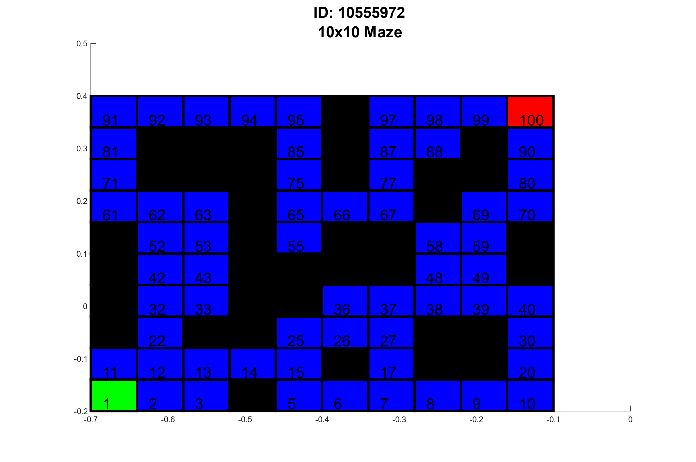

## Generate Random Start State

To begin with I have implemented a function that randomly generates a starting state within the maze. This starting state must not be a blocked or the goal state of the maze. This is shown as a histogram below when generating 1000 random starting states. It is clear here that there are 0 occurrences for the blocked and goal states.

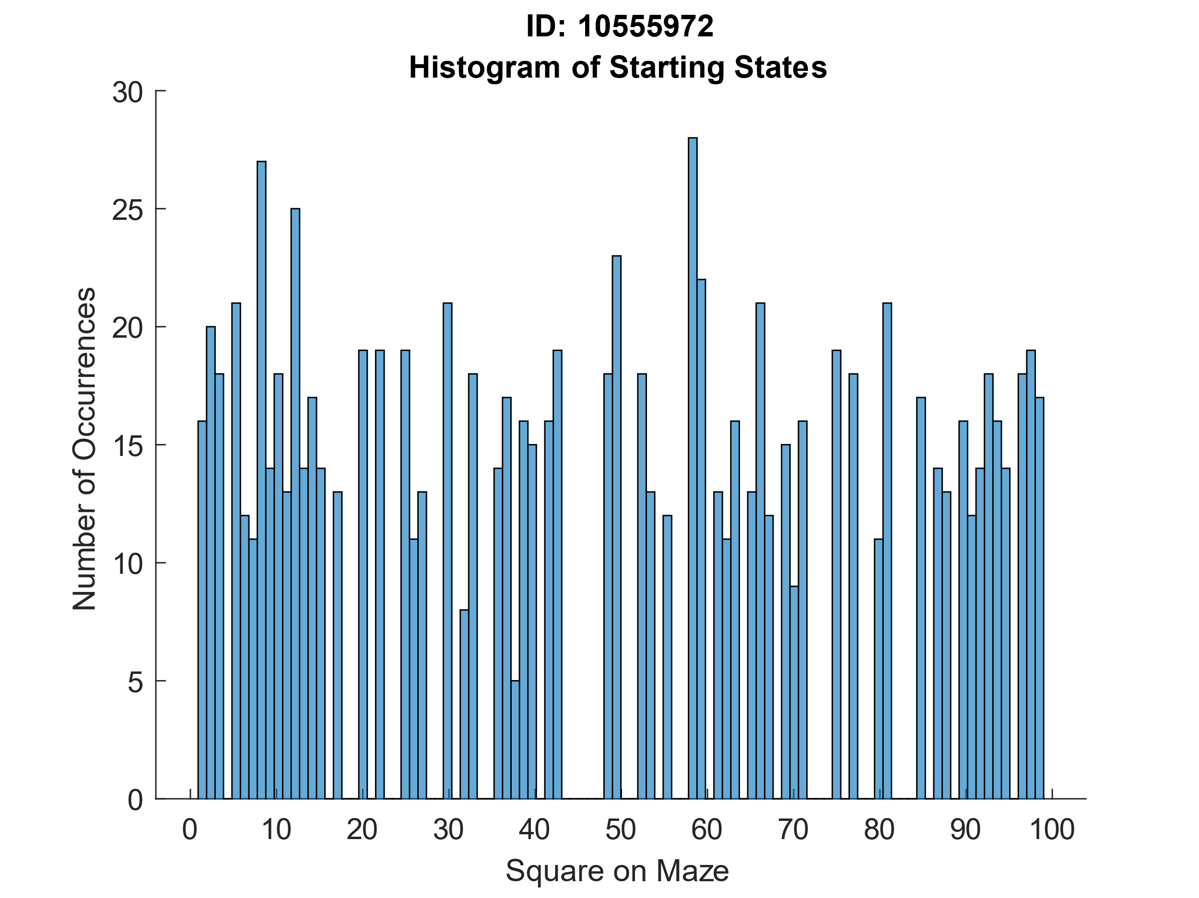

% Function to compute a random starting state between 0 and 100 not

% including blocked states

function startingState = RandomStartingState(f)

% Initial values

allowed = false;

b = 100;

while (allowed == false)

% Getting a random starting state

startingState = ceil(b*rand);

% Checking if starting state is in the blockedLocations array

for i = 1:size(f.blockedLocations)

% Getting tile number

sidx=f.stateNumber(f.blockedLocations(i, 1),f.blockedLocations(i, 2));

% Changing bool value depending on if state is allowed or not

if (sidx == startingState)

allowed = false;

break;

else

allowed = true;

end

end

end

end

## Build a Reward Function

Below is a reward function that rewards the algorithm if the correct action is taken when in a certain state to then reach the goal state.

% Reward function that takes a stateID and an action

function reward = RewardFunction(f, stateID, action)

if ((stateID == 90 && action == 1) || (stateID == 99 && action == 4))

reward = 10;

else

reward = 0;

end

end

## Generate a Transition Matrix

A transition matrix is a matrix that defines a new state given a current state and an action. Below is a function I have implements to generate a transition matrix for me given the 4 possible actions that can be taken.

% Function to build the transition matrix

function f = BuildTransitionMatrix(f)

% Defining actions

north = 1; east = 2; south = 3; west = 4;

% Loop through each state

for i = 1:f.xStateCnt

for j = 1:f.yStateCnt

% Check if state is open

if (f.stateOpen(i, j))

sidx=f.stateNumber(i,j);

% Loop through each possible action

for k = 1:4

if (k == north)

% Increase or decrease coordinates depending on action

if (i > 0 && i <= 10 && j > 0 && j <= 9)

if (f.stateOpen(i, j + 1))

f.tm(sidx, k) = f.stateNumber(i,j + 1);

else

f.tm(sidx, k) = f.stateNumber(i,j);

end

else

f.tm(sidx, k) = f.stateNumber(i,j);

end

elseif(k == east)

if (i > 1 && i <= 10 && j > 0 && j <= 10)

if (f.stateOpen(i - 1, j))

f.tm(sidx, k) = f.stateNumber(i - 1,j);

else

f.tm(sidx, k) = f.stateNumber(i,j);

end

else

f.tm(sidx, k) = f.stateNumber(i,j);

end

elseif(k == south)

if (i > 0 && i <= 10 && j > 1 && j <= 10)

if (f.stateOpen(i, j - 1))

f.tm(sidx, k) = f.stateNumber(i,j - 1);

else

f.tm(sidx, k) = f.stateNumber(i,j);

end

else

f.tm(sidx, k) = f.stateNumber(i,j);

end

elseif(k == west)

if (i > 0 && i <= 9 && j > 0 && j <= 10)

if (f.stateOpen(i + 1, j))

f.tm(sidx, k) = f.stateNumber(i + 1, j);

else

f.tm(sidx, k) = f.stateNumber(i,j);

end

else

f.tm(sidx, k) = f.stateNumber(i,j);

end

end

end

end

end

end

end

## Initialize Q-Values

The next step is to generate a table for the Q-Values to be stored. This is a 100x4 size matrix as there is 100 states all with a possible 4 actions, all the values are randomised between 0.01 and 0.1. These Q-Values will be modified throughout the experiment depending on the discount and learning rate. These values will determine what route the algorithm will take through the maze.

% Intialise the Q-Table

function f = InitQTable(f, minVal, maxVal)

f.QValues=(maxVal-minVal).*rand(f.totalStateCnt, f.actionCnt) + minVal;

end

## Implement Q-Learning Algorithm

To implement the Q-Learning algorithm I have set up the experiment to run for 100 trials, each with 1000 episodes. Each episode loops until the termination state is reached, the number of steps taken in an episode is recorded as this shows how well the algorithm is performing.

During each episode the next action is chosen by using a greedy action selection. This happens by getting the maximum value from the Q-Values for that state which corresponds to an action 90% of the time, the remaining 10% of the time it will randomly pick an action. This is known as the exploration part of the algorithm. After an action is determined, the next state can be found using the transition matrix as well as the reward by using the reward function previously defined.

Now by using the Q-Learning equation we can update a value in the Q-Table:

Where:

= Learning Rate

= Reward

= Discount Rate

= Next state and action

= Current state and action

% Calculates mean and std and runs the number of trials

function [meanVal, stdVal, stepsAcrossTrials, coordinates] Experiment(maze, episodes, trials)

% Loops through number of trials

for i = 1:trials

[maze, stepsAcrossTrials(i, :)] = Trial(maze, episodes);

end

meanVal = mean(stepsAcrossTrials);

stdVal = std(stepsAcrossTrials);

% Gets coordinates for the final optimal route through maze

coordinates = GetCoordinates(maze);

end

% Defines termination state and runs through the number of episodes

function [maze, steps] = Trial(maze, episodes)

terminationState = 100;

for i = 1:episodes

[maze, steps(i)] = Episode(maze, terminationState);

end

end

% Implementation of a Q-Learning episode

function [maze, steps] = Episode(maze, terminationState)

% Defining initial values

running = 1;

steps = 0;

state = maze.RandomStartingState();

% Loops until termination state is reached

while (running == 1)

% Getting action, the next state, and the reward

action = GreedyActionSelection(maze, state);

nextState = maze.tm(state, action);

reward = maze.RewardFunction(state, action);

% Gets updated maze object, including the updates QValues

maze = UpdateQ(maze, state, action, nextState, reward);

% Termination condition

if(nextState == terminationState)

running = 0;

end

% Updating no. of steps and the current state

steps = steps + 1;

state = nextState;

end

end

% Using Q-Algorithm to update a value in the QValues using the learning and discount rate

function maze = UpdateQ(maze, state, action, resultingState, reward)

a = 0.2;

y = 0.9;

maze.QValues(state, action) = maze.QValues(state, action) + a * (reward + y * max(maze.QValues(resultingState, :)) - maze.QValues(state, action));

end

% Selects the maximum value at any given state from QValues and returns the action 90% of the time. 10% of the time it will "explore" and return a random value

function action = GreedyActionSelection(maze, state)

% Calculating random probability

p = rand(1);

if (p > 0.9)

% Return random action if greater than 0.9 (10%)

a = 0;

b = 4;

action = ceil((b-a) * rand + a);

else

% Return the index of the maximum value of the current state

[temp, action] = max(maze.QValues(state, :));

end

end

## Run Q-Learning

When running the Q-Learning algorithm I have used the values 0.9 for my discount rate and 0.2 as my learning rate. For each episode I have stored the number of steps taken to reach the goal state and plotted an error bar graph using the mean and standard deviation for each episode.

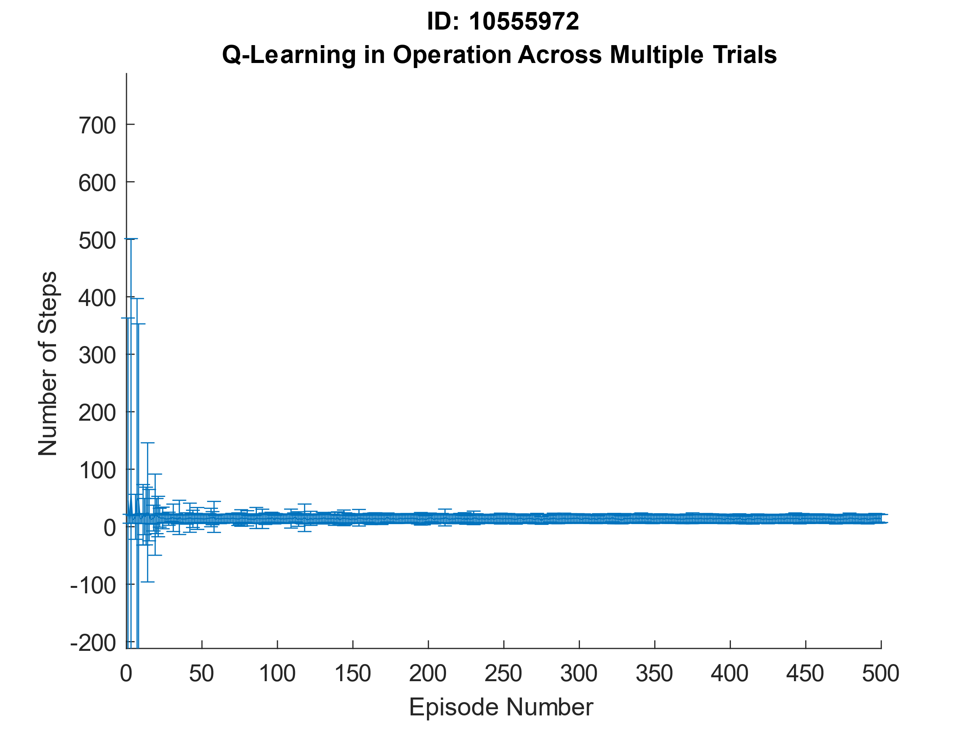

## Exploitation of Q-Values

After the entire experiment has completed, I can use the Q-Values and make a greedy action selection without exploration to find the most optimal route through the maze. I do this by making the starting state 1 and taking the maximum value in the table for that state to get the next action. This action is then used to obtain the next state. This continues to happen until the termination state is reached. I store all the coordinates throughout this process to be able to print onto the maze as shown below.

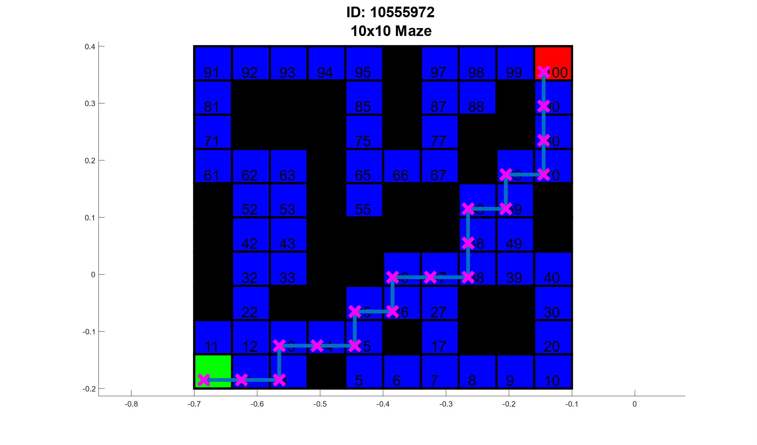

% Returns the coordinates of the most optimal route through the maze

function coordinates = GetCoordinates(maze)

% Setting intial values

termination = false;

i = 1;

states(i) = 1;

while (termination == false)

% Calculate action from QValues depending what state

[temp, action] = max(maze.QValues(states(i), :));

% Update the state given the action

states(i + 1) = maze.tm(states(i), action);

% Termination condition

if(states(i + 1) == 100)

termination = true;

end

% Get the coordinates of the current state

coordinates(1, i) = maze.stateX(states(i));

coordinates(2, i) = maze.stateY(states(i));

i = i + 1;

end

% Get final coordinates

coordinates(1, i) = maze.stateX(states(i));

coordinates(2, i) = maze.stateY(states(i));

end

# Move arm Endpoint Through Maze

The final part is to use the maze path and plot the endpoints of the arm to follow through the maze. This will be achieved by taking the coordinates that have been stored by calculating the most optimal route through the maze and passing them through the trained neural network to get the revolute arm angles to be able to plot the arm onto the maze.

## Generate Kinematic Control to Revolute Arm

To plot the robot arm onto the maze, first I must take the scaled coordinates and completed a feedforward pass on them to get the angles of the arm. I then take those angles and run them through the forward kinematics function to get the arm endpoints. I then plot the maze with the calculated route from the Q-Learning algorithm and then plot the arm endpoints along with the connecting lines on top of the maze. I have scaled the maze to ensure that the entire arm will fit into the workspace without distorting the maze.

% Passing scaled coordinated through network to get arm angles

for i = 1:size(scaledCoordinates,2)

outputtedAngles(:,i) = FeedForward([scaledCoordinates(1,i) ; scaledCoordinates(2,i)], W1, W2);

end

% Defining variables and passing outputted arm angles to get endpoints

armLength = [0.4;0.4]; baseOrigin = [0, 0];

[P1, P2] = RevoluteForwardKinematics2D(armLength, outputtedAngles, baseOrigin);

% Drawing the maze and plotting the route to termination state

maze.DrawMaze();

title({'ID: 10555972', '10x10 Maze'});

xlim([-0.8 0.4]);

ylim([-0.3 0.6]);

line(scaledCoordinates(1,:), scaledCoordinates(2,:), 'Marker', 'x', 'MarkerEdgeColor', 'm','MarkerFaceColor', [1, 0, 1], 'MarkerSize', 20, 'LineWidth', 5);

% Plotting points with arm, connecting to origin

for i = 1:19

plot([P1(1,i) P2(1,i)],[P1(2,i) P2(2,i)], 'r-o', 'MarkerSize', 5, 'MarkerFaceColor', 'green');

plot([P1(1,i) baseOrigin(1)], [P1(2,i) baseOrigin(2)], 'r-o', 'MarkerSize', 5);

end

## Animated Revolute Arm Movement

Below is a screenshot of the arm endpoints from the network plotted on top of the maze. I have also included a link to an animation of the arm moving through the maze.

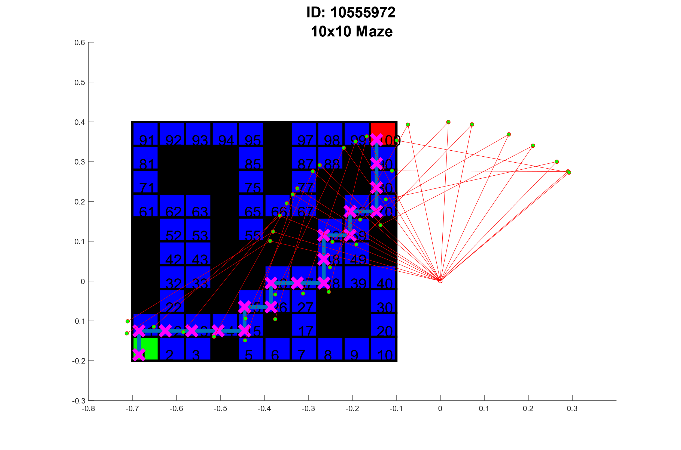

<https://www.youtube.com/watch?v=bdKctw_1Dq0>